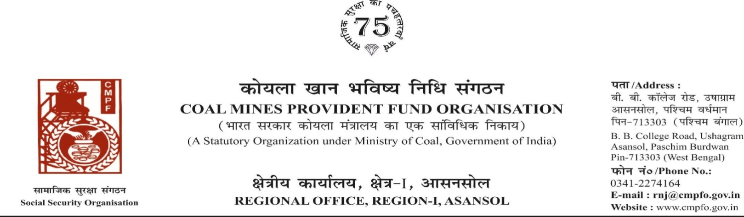

Ref. : CPF/118/Misc/RNJ/LC/OUT/R-I/ASN/ Date : 10/11/2024
To,

The Regional Commissioner
Coal Mines Provident Fund Organisation
Near T. B. Sanatorium, Chhindwara
Pin-48001 (Madhya Pradesh)

Sub- : Inter Regional Transfer of Ledger Card, DA, PS -3 & 4

Sir,
In view of the revised procedure prescribed in procedure office order No-230 Dated-12/02/1973 of CMPF Commissioner, Dhanbad, I am to state that the ledger card of the following member is forwarded to your office as he is working under jurisdiction of your region.
It is ensured that the posting in the ledger card are dully completed for the periods for which the member was contributing in this region.
SL. No | Name of the member | CMPF A/C No | Name of the colly where member worked in this region | Name o the colliery where member working in your region
1 | Biswajit Roy | RNJ/17/1860 | Khandra Colliery  (RNJ/21)  From 01.9.2016 | Vishnupuri Ug. No.-1 (Pench)  From 29.04.2012 to 31.08.2016

Yours faithfully,
.

Encl. : As above

Assistant Commissioner




Ref. : CPF/118/Misc/RNJ/LC/OUT/R-I/ASN/ Date : 27/06/2025

To,

The Regional Commissioner
Coal Mines Provident Fund
Ranchi , R-II
Ranchi (jharkhand)
PIN-834001

Sub- : Inter Regional Transfer of Ledger Card, DA, PS -3 & 4
Sir,
In view of the revised Procedures prescribed in Procedure Office Order No-35 Dated-12.02.1975 of CMPF Commissioner,Dhanbad, I am to state that the Ledger Cards of the following members along with Declaration in Form "A" Form-I (Pen),PS-3 & 4 may kindly be forwarded to this office as the member(s) is /are working in this region.
It may kindly be ensured that the posting in the Ledger Cards may be made updated for the periods the member was working in your Region.
Member will be superannuate on 31st January, 2025. Refund claim received to this office under Mission Biswas.
SL. No | Name of the member | CMPF A/C No | Name of the colly where member worked in this region | Name o the colliery where member working in your region
1 | Sri Malay Chandan Chandra | KGL/17/1602 | Kathara colliery,kithara area,CCL | Kumardihi b colliery  (RNJ/18)

Encl. : Posting Details

Yours faithfully

Assistant Commissioner



CPF/118/Misc/Ext-out/R-I/ASN/ Dated-27/06/2025

To,
The regional Commissioner
CMPFO,SBP
P.O.-Jagrutivihar, Dist.-Sambalpur
State - Odisha, PIN- 768020

Sub- Supply of Extract of "VV" statement

Sir,

On the subject and reference cited above, enclosed please find herewith the extract in r/o-
Sri Kishore Ram Ratan CMPF A/C No- BBSR/23/30 as required. Ledger Card is not available in this region.

Encl- As above

Yours faithfully

Assistant Commissioner

